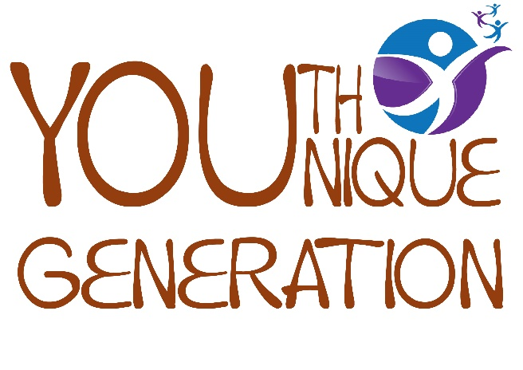
PITSEA POUND POT

Guidance notes

Youth YOUnique Generation is a youth forum set up by Heart of Pitsea to give a voice to local young people. Our unique group receive a quarterly budget to put towards local projects, primarily aimed at children and young people in the area. The Pitsea Pound Pot is a brand-new scheme we have created which encourages organisations to apply for up to £1500 towards a project that will be delivered in the Heart of Pitsea area to benefit local children and young people. Any type of organisation can apply for money, but individuals cannot. The minimum value is £200.
Project ideas will be assessed and exclusively voted on by youth forum members at our regular fortnightly meetings. It is a rolling programme which means any organisation can apply at any time. A decision will be made within eight weeks of a project submission. Organisations will be notified of the receipt of their idea and the latest date they can expect to receive a decision from us.
All projects put forward must make an impact towards the four Big Local outcomes and must address at least one of our two main themes: Health, Wellbeing and Activities / Safer & Cleaner Community. All organisations rewarded from the Pitsea Pound Pot will be required to use our easy online Monitoring and Evaluation tool. This means we can keep track of projects throughout all stages of delivery. All projects must take place within the designated Heart of Pitsea boundaries. You will need to download our Heart of Pitsea map to check. Further information is provided in Heart of Pitsea’s Big Local Plan 2021-24 which was created through extensive consultation with local residents and can be downloaded from the Heart of Pitsea website.
The Big Local outcomes are:
- Communities will be better able to identify local needs and take action in response to them.
- People will have increased skills and confidence, so that they continue to identify and respond to needs in the future.
- The community will make a difference to the needs it prioritises.
- People will feel that their area is an even better place to live.

Our two themes relevant to the Pitsea Pound Pot application scheme are:
HEALTH, WELLBEING and ACTIVITIES

As a result of our work we would like to see the following outcomes:
- People being more active, with more opportunities to be active
- Improved mental health (including a reduction in feelings of isolation)
- Greater support for those living with health issues
- Increased participation with people leading a healthier lifestyle.

SAFER & CLEANER COMMUNITY

As a result of our work we would like to see the following outcomes:
- Improvements to our local green spaces
- A decrease in anti-social behaviour
- More opportunities for people to come together as a community
- A decrease in the fear of crime amongst residents

The online Pitsea Pound Pot project form has 13 easy-to-complete stages - here are some notes to guide you:

1. NAME OF ORGANISATION – please simply print the name of your organisation
2. TYPE OF ORGANISATION – simply state whether you are a charity, voluntary group, business, statutory body or other kind of organisation
3. CONTACT DETAILS – fill in all of the relevant details
4. PROJECT NAME – please give your project a named identity
5. PROJECT DESCRIPTION – you can use up to 500 words to describe what your project is all about
6. PROJECT DURATION – please state how long your project will last for: it could be a one-off workshop, a series of six events or possibly a weekend of activities
7. PROJECT LOCATION – although you may not have an exact location, please give an idea of where you intend to run your project
8. PROJECT BENEFICIARIES – describe who will benefit from your project, perhaps by providing an age-group and a prospective quantity
9. PROJECT OUTCOMES – provide up to 4 bullet-points which describe the outcomes of your project – for example, increased confidence or improved knowledge
10. PROJECT TIMEFRAMES – give some idea of when you are hoping your project will begin and end. This can include planning stages before and evaluating stages at the end
11. PROJECT BUDGET – this is an important part of the form and we need you to provide us with an outline of what you intend to spend the money on, in addition to any other costings. This budget should include any contributions your own organisation is making, which could be volunteer time (valued at £11.09 per hour), services provided for free or a cash contribution
12. YOUTH YOUNIQUE GENERATION CONTRIBUTION – this simply needs to give the total figure your organisation is requesting from Youth YOUnique Generation’s Pitsea Pound Pot. Remember, this can be between £200 and £1500
13. PROJECT SUBMISSION DATE – this is the date you are submitting your form.

If a project idea is successful, Youth YOUnique Generation will offer an official Project Agreement which will briefly outline the final project budget, payment schedule, deliverable objectives, suitable timeframes, expected outputs and project authorisation. Both this document and your original Project Form will be used together throughout the duration of the project. Should you require any assistance in completing your project form or simply require more information, please contact Tracey Griffith, Heart of Pitsea Co-Ordinator on 07572 001671.

