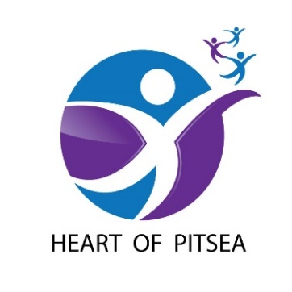
PROJECT PROPOSALS

Guidance notes

Our Project Proposal process has been created to enable charities, voluntary organisations, CICs/CIOs, statutory bodies and businesses to put forward solid ideas which will help us to achieve the organisation’s objectives. (Please note, statutory bodies are not eligible to recuperate any staffing costs as this is a Government expense not covered by the Big Local scheme). Proposals are assessed by the governing Partnership Board which comprises a combination of local residents and representatives from four strategic partners. Any decisions to progress a submitted proposal rests with the residents who are the only members with voting rights. All projects must take place within the designated Heart of Pitsea boundaries. You will need to download our Heart of Pitsea map to check. It is a rolling programme so there are no deadlines for submissions – proposals can be made at any time.
Organisations will be informed of decisions within six weeks of each deadline date.
Any proposal must address at least one of our three main themes: Health, Skills and Community. It is expected that all proposals will provide added value by including some kind of contribution to the project – this could be in the form of part funding, matched funding, volunteer time, in-kind resources or generated income. It is expected that all projects will benefit those who live, work or go to school within the Heart of Pitsea area, though it is appreciated that a project may also impact on areas outside the boundaries in neighbouring areas. Consideration will also be given to the scale of a project and how many members of the local community it will benefit. The funding that has been allocated for the Heart of Pitsea has clear guidelines which specify that projects should make a long-lasting or positive change to the local community for the future. The Heart of Pitsea Partnership Board are keen to support projects that are innovative, unique and designed for the benefit of local people. They are interested to know what the legacy of your project will be and the impact you expect it to make. They will not support projects that offer poor value for money or do not specifically impact the local community. Our Big Local Plan 2018-21 was created through extensive consultation with local residents. It is essential you refer to this document for information, which is available to download from the Heart of Pitsea website.
All projects that are supported will need to make an impact towards achieving the four Big Local outcomes and the identified outcomes of our themes. To evidence this, all projects will need scope for excellent monitoring and evaluation throughout. All organisations that are awarded funding will be required to use our online Monitoring and Evaluation tool. This allows the Partnership Board to see the progression of all projects throughout all stages of delivery.
The Big Local outcomes are:
- Communities will be better able to identify local needs and take action in response to them.
- People will have increased skills and confidence, so that they continue to identify and respond to needs in the future.
- The community will make a difference to the needs it prioritises.
- People will feel that their area is an even better place to live.

Our three themes relevant to the proposal process are:
HEALTH

As a result of our work we would like to see the following outcomes:
- People being more active, with more opportunities to be active
- Improved mental health (including a reduction in feelings of isolation)
- Greater support for those living with health issues
- Increased participation with people leading a healthier lifestyle.

SKILLS

As a result of our work we would like to see the following outcomes:
- Increased participation/attendance in activities for young people
- A greater number of training courses available
- More instructional workshops and events
- Increased participation of local business in employment initiatives.

COMMUNITY

As a result of our work we would like to see the following outcomes:
- Improvements to our local green spaces
- A decrease in anti-social behaviour
- More opportunities for people to come together as a community
- A decrease in the fear of crime amongst residents

If a Project Proposal is successful, Heart of Pitsea will offer an official Project Agreement which will outline the final project budget, payment schedule, deliverable objectives, suitable timeframes, expected outputs and project authorisation. Both documents will be used in tandem throughout the duration of the project. Should you require any assistance in completing your proposal or simply require more information, please contact Simon Johnson, Heart of Pitsea Co-Ordinator on 07572 001671.

